**Chapter 6**

**Vector Calculus**

**6.7 Stokes’ Theorem**

**Section Exercises**

**For the following exercises, without using Stokes’ theorem, calculate directly both the flux of  over the given surface and the circulation integral around its boundary, assuming all boundaries are oriented clockwise as viewed from above.**

1.  *S* is the first-octant portion of plane 

Answer: 

1.  *S* is hemisphere 

Answer: 

1.  *S* is hemisphere 

Answer: 

1.  *S* is upper hemisphere 

Answer: 

1.  *S* is a triangular region with vertices

(3, 0, 0), (0, 3/2, 0), and (0, 0, 3).

Answer: 

1.  *S* is a portion of paraboloid  and is above the *xy*-plane.

Answer: 

**For the following exercises, use Stokes’ theorem to evaluate  for the vector fields and surface.**

1.  and *S* is the surface of the cube  except for the face where  and using the outward unit normal vector.

Answer: 

1.  and *C* is the intersection of paraboloid  and plane  and using the outward normal vector.

Answer: 

1.  and *C* is the intersection of sphere  with plane  and using the outward normal vector

Answer: 

1. Use Stokes’ theorem to evaluate  where *C* is the curve given by  traversed in the direction of increasing *t*.

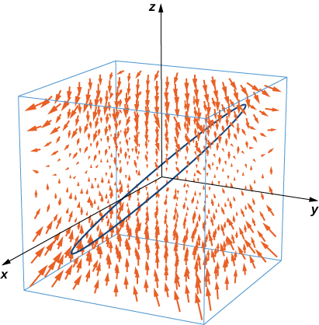

Answer: 

1. **[T]** Use a computer algebraic system (CAS) and Stokes’ theorem to approximate line integral  where *C* is the intersection of plane  and surface  traversed counterclockwise viewed from the origin.

Answer: 

1. **[T]** Use a CAS and Stokes’ theorem to approximate line integral  where *C* is the intersection of the *xy*-plane and hemisphere  traversed counterclockwise viewed from the top—that is, from the positive *z*-axis toward the *xy*-plane.

Answer: 

1. **[T]** Use a CAS and Stokes’ theorem to approximate line integral  where *C* is a triangle with vertices , , and  oriented counterclockwise.

Answer: 

1. Use Stokes’ theorem to evaluate  where  and *S* is half of sphere  oriented out toward the positive *x*-axis.

Answer: 

1. **[T]** Use a CAS and Stokes’ theorem to evaluate , where  and *C* is the curve of the intersection of plane  and cylinder  oriented clockwise when viewed from above.

Answer: 

1. **[T]** Use a CAS and Stokes’ theorem to evaluate  where  and *S* consists of the top and the four sides but not the bottomof the cube with vertices  oriented outward.

Answer: 

1. **[T]** Use a CAS and Stokes’ theorem to evaluate  where  and *S* is the top partof  above plane  and *S* is oriented upward.

Answer: 

1. Use Stokes’ theorem to evaluate , where  and *S* is a triangle with vertices (1, 0, 0), (0, 1, 0) and (0, 0, 1) with counterclockwise orientation.

Answer: 

1. Use Stokes’ theorem to evaluate line integral  where *C* is a triangle with vertices (3, 0, 0), (0, 0, 2), and (0, 6, 0) traversed in the given order.

Answer: 

1. Use Stokes’ theorem to evaluate  where *C* is the curve of intersection of plane  and ellipsoid  oriented clockwise from the origin.

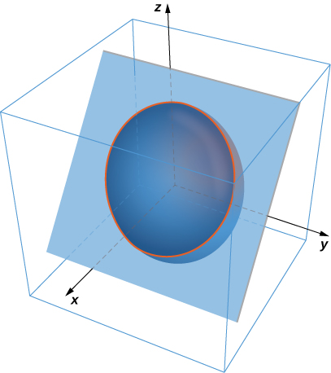

Answer: 

1. Use Stokes’ theorem to evaluate  where  and *S* is the part of surface  with  oriented counterclockwise.

Answer: 

1. Use Stokes’ theorem for vector field  where *S* is surface  *C* is boundary circle  and *S* is oriented in the positive *z*-direction.

Answer: 

1. Use Stokes’ theorem for vector field  where *S* is that part of the surface of plane  contained within triangle *C* with vertices (1, 0, 0), (0, 1, 0), and (0, 0, 1), traversed counterclockwise as viewed from above.

Answer: 

1. A certain closed path *C* in plane  is known to project onto unit circle  in the *xy*-plane. Let *c* be a constant and let  Use Stokes’ theorem to evaluate .

Answer: 

1. Use Stokes’ theorem and let *C* be the boundary of surface  with  and  oriented with upward facing normal. Define

and evaluate .

Answer: 

1. Let *S* be hemisphere  with , oriented upward. Let  be a vector field. Use Stokes’ theorem to evaluate 

Answer: 

1. Let  and let *S* be the graph of function  with  oriented so that the normal vector *S* has a positive *y* component. Use Stokes’ theorem to compute integral .

Answer: 

1. Use Stokes’ theorem to evaluate , where  and *C* is a triangle with vertices (0, 0, 0), (2, 0, 0) and  oriented counterclockwise when viewed from above.

Answer: 

1. Use the surface integral in Stokes’ theorem to calculate the circulation of field **F**,around *C*,which is the intersection of cylinder  and hemisphere  oriented counterclockwise when viewed from above.

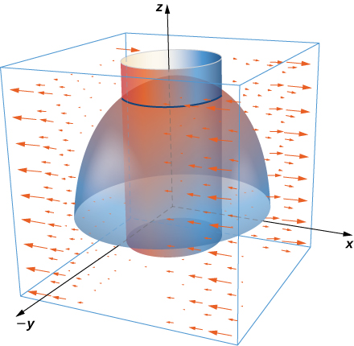

Answer: 

1. Use Stokes’ theorem to compute  where  and *S* is a part of plane  inside cylinder  and oriented counterclockwise.

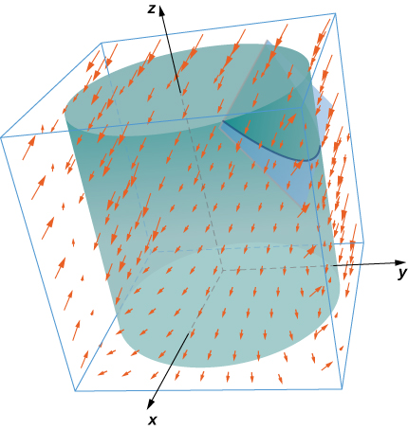

Answer: 

1. Use Stokes’ theorem to evaluate , where  and *S* is the part of plane  in the positive octant and oriented counterclockwise 

Answer: 

1. Let  and let *C* be the intersection of plane  and cylinder  which is oriented counterclockwise when viewed from the top. Compute the line integral of **F** over *C* using Stokes’ theorem.

Answer: 

1. **[T]** Use a CAS and let  Use Stokes’ theorem to compute the surface integral of curl **F** over surface *S* with inward orientation consisting of cube  with the right side missing.

Answer: 

1. Let *S* be ellipsoid  oriented counterclockwise and let **F** be a vector field with component functions that have continuous partial derivatives.

Answer: 

1. Let *S* be the part of paraboloid  with  Verify Stokes’ theorem for vector field 

Answer: 

1. **[T]** Use a CAS and Stokes’ theorem to evaluate  if  where *C* is the curve given by 

Answer: 

1. **[T]** Use a CAS and Stokes’ theorem to evaluate  with *S* as a portion of paraboloid  cut off by the *xy*-plane oriented counterclockwise.

Answer: 

1. **[T]** Use a CAS to evaluate  where  and ***S*** is the surface parametrically by  

Answer: 

1. Let *S* be paraboloid  for  where is a real number. Let  For what value(s) of *a* (if any) does  have its maximum value?

Answer:  for all *a*.

**For the following application exercises, the goal is to evaluate**

**where  and *S* is the upper half of ellipsoid**



1. Evaluate a surface integral over a more convenient surface to find the value of *A*.

Answer: 

1. Evaluate *A* using a line integral.

Answer: 

1. Take paraboloid  for  and slice it with plane  Let *S* be the surface that remains for , including the planar surface in the *xz*-plane. Let *C* be the semicircle and line segment that bounded the cap of *S* in plane  with counterclockwise orientation. Let  Evaluate

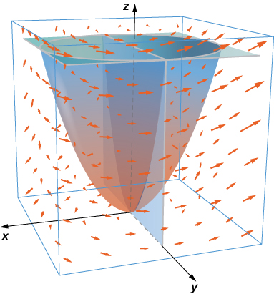

Answer: 

**For the following exercises, let *S* be the disk enclosed by curve for  where  is a fixed angle.**

1. What is the length of *C* in terms of 

Answer: 

1. What is the circulation of *C* of vector field  as a function of 

Answer: 

1. For what value of  is the circulation a maximum?

Answer: Maximum for 

1. Circle *C* in plane  has radius 4 and center (2, 3, 3). Evaluate  for  where *C* has a counterclockwise orientation when viewed from above.

Answer: 

1. Velocity field , for  represents a horizontal flow in the *y*-direction. Compute the curl of **v** in a clockwise rotation.

Answer: 

1. Evaluate integral where and *S* is the cap of paraboloid  above plane , and **n** points in the positive *z*-direction on *S*.

Answer: 

**For the following exercises, use Stokes’ theorem to find the circulation of the following vector fields around any smooth, simple closed curve C.**

1. 

Answer: 0

1. 

Answer: 0

This file is copyright 2016, Rice University. All Rights Reserved.